2021 Crosby Middle School Football Shirt

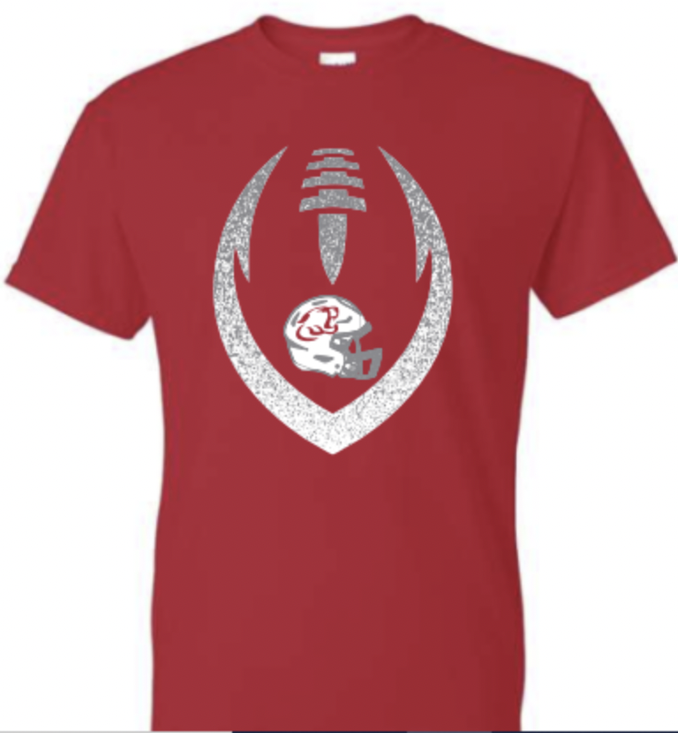

Price: $15- YS, YM, YL, S, M, L, XL, 2X $18- 3X $20- 4X

Name: __________________________________________

Size (Quantity): YS ( ) YM ( ) YL ( ) YXL ( ) S ( ) M ( ) L ( ) XL ( ) XXL ( ) 3XL ( ) 4XL ( )

Total Due $:________________

Please bring to CMS Front office with exact amount and send with note: Attn: Coach Wilson Football T-Shirt Order Form
OR
Send money and order form with student to Coach Wilson

